Insights Cockpit
Functional Requirements

Contents
Status Summary 3
Functional requirements 4
1. Login 4
2. Site Navigation 5
3. Admin Page 5
4. Company Overview 5
5. Assessment Selection and setup 6
6. Data upload page 12
7. Explore and adjust Baseline 14
8. Benchmarking 14
9. Shared Services 17
10. Automation 19
11. Cross-tool Integration 19
12. GenAI 19
13. Backlog 19
1. Advanced 19
2. Good to have 19

Status Summary
Sno | Feature | Status | Comments | Requirement Sign off
1 | Company overview page | Live
2 | Assessment selection page | Live
3 | HR Baseline Template download page | Live
4 | Uploads page | Live
5 | Benchmarking | Live
6 | SSOI | UI ready. Dev to be started
7 | Automation | TBD

Functional requirements

Login

Users to get access to application by being added to the Okta user group . SSO Login: All Bain users (added to the above group) have SSO login enabled. Users have access to only limited case(s) which will be controlled by the admin users. Initially this is controlled by running SQL queries to add/modify user access with Admin page to be added post MVP. On Login user will land on Home page with a list of cases accessible to the user or can create a new case. Below is a tentative landing page design
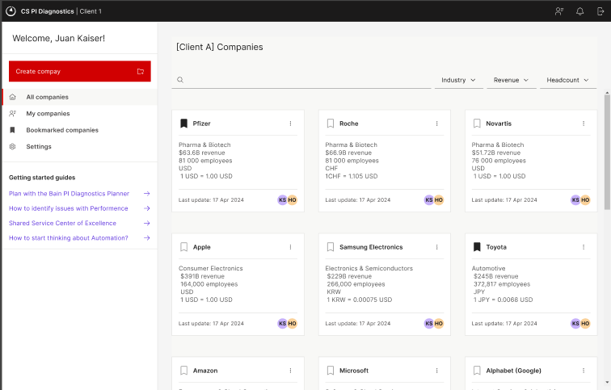

Site Navigation
- Navigation Bar
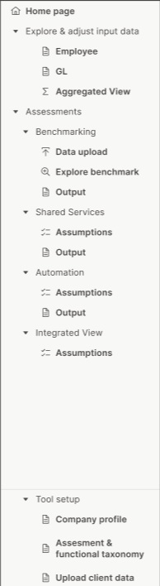

Navigation bar is case specific. It will display only the options depending on the assessments selected by the user.
At the bottom of the navigation bar is the “Tool Setup” menu. Users can use these options to go to the setup pages at any time during the analysis.
When a user start creating a case for the first time, they will not see any navigation bar. The navigation is made visible only after the user has completed the tool setup process.

Admin Page
- To be picked later

Company Overview
- Purpose
This is the Landing page for the user when starting a new case. This will collect high level info regarding the company

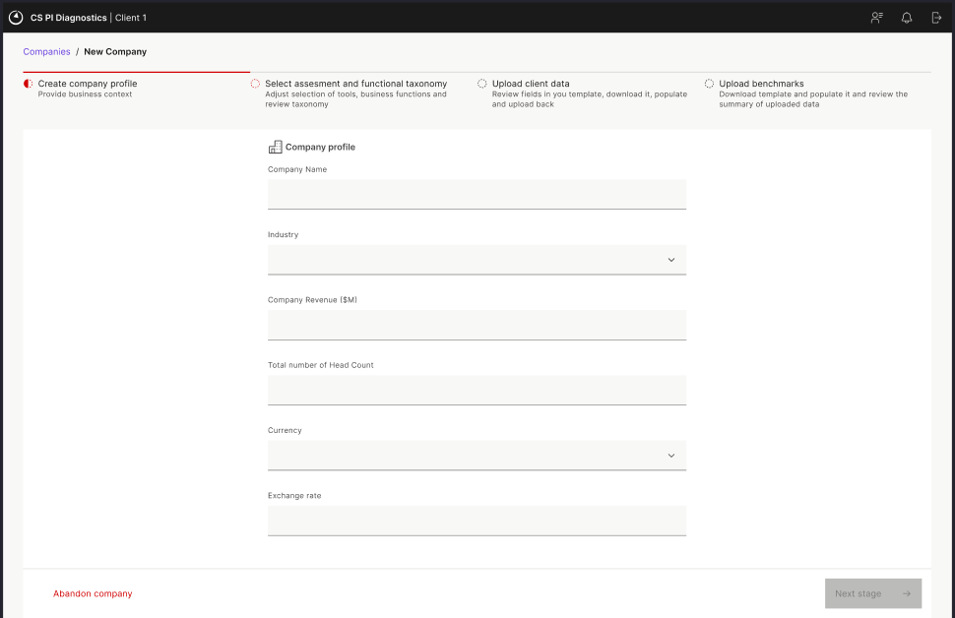
- Validations:
- All fields are mandatory
- No of employees cannot be negative and should only input numbers
- Exchange rate should be >0
- Company revenue should be >0

- Click actions:
- Abandon company: Any details entered are removed and user is redirected to Home page. No new case is created
- Next Stage: Check all validations are met. A new case is created in the database. User is directed to the assessment selection page

- Form actions:
- Exchange rate will be populated from a standard table in the DB. The exchange rate data will be updated on a quarterly basis by the COE. However, the user has rights to update the exchange rate manually.

Assessment Selection and setup
  - Purpose
This page captures the assessments that the user wants to run

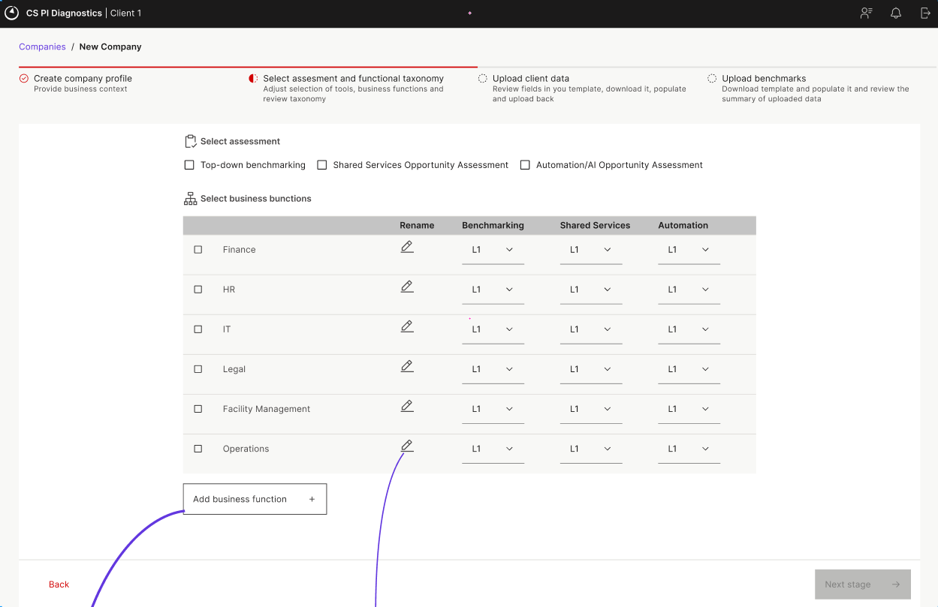
  - Page actions:
- Assessment selection : Users can select one or more assessments. Based on the assessment selected, business functions displayed would vary.
Ex: If a user selects only Benchmarking and “Operations” function is not present for it , then it will not be shown in the list
Key note:
- Functions and granularity level selection:
  - Relevant functions to be displayed based on assessments selected
  - For all assessments “L2” to be selected by default
  - In case a selected level is not applicable for an assessment, when a user selects that level, they will get an error immediately below the dropdown saying “No benchmarks available”
  - All functions to be assorted as given in figma. Any new custom fields added by user will be added at the bottom of the list.

- Feature /Processes/Activities selection page
- Once the features are selected, user moves to the next page to select L2 and L3 layer. Only the functions selected in previous pages are displayed here.
- Users can click on the “Edit” button to display the list of L2 levels for the Function.
- L2 levels will be displayed as editable text that the user can easily rename them.
- L3 levels will be shown as a slidedown when a L2 level is clicked upon. These will also be editable directly
- Users can add both custom L2 and L3 levels but if they define a L2 level they are responsible to define the lower L3 hierarchy for the same

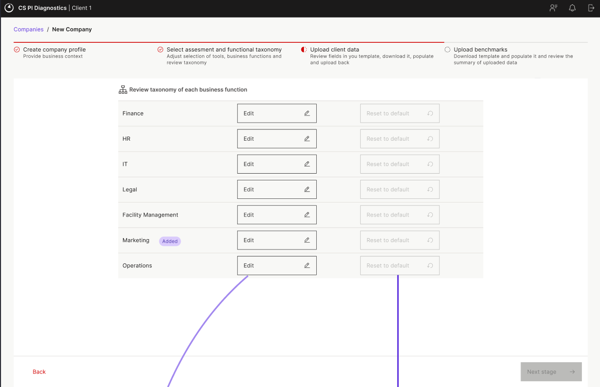

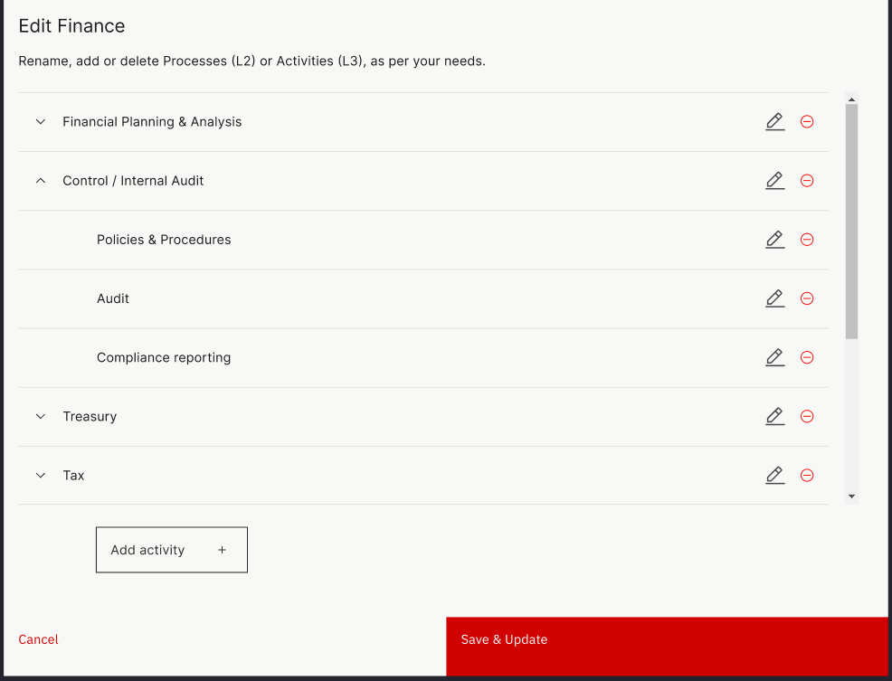

- Template column selection page
- Users will select the template they want to input data. The options are dependent on the assessment selected. HRIS and GL files are present for all assessments but a third option appears for Outsourced files if a user selects SSOI as one of the assessments.
- The user can then select the relevant columns for which they plan to run the assessments
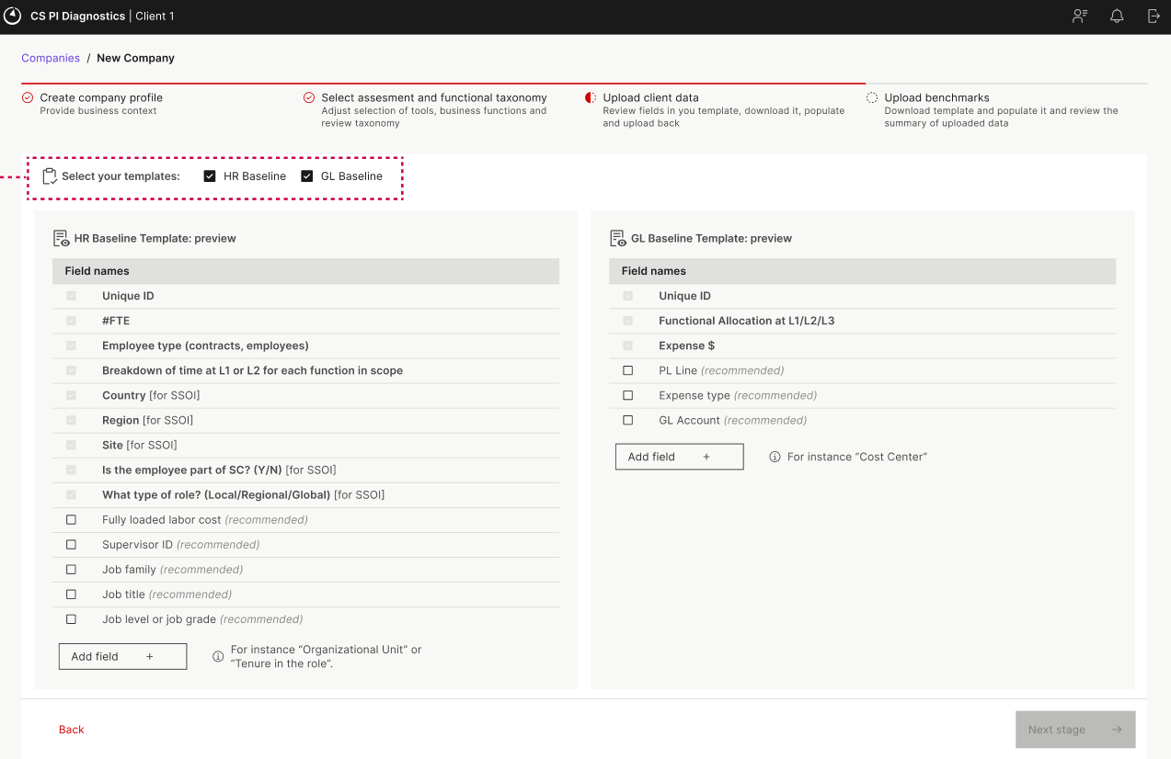

- Upload templates
- Users will upload the Baseline data from this page. The columns included in the files are dynamic as they are dependent on the selections made by the user in previous step.
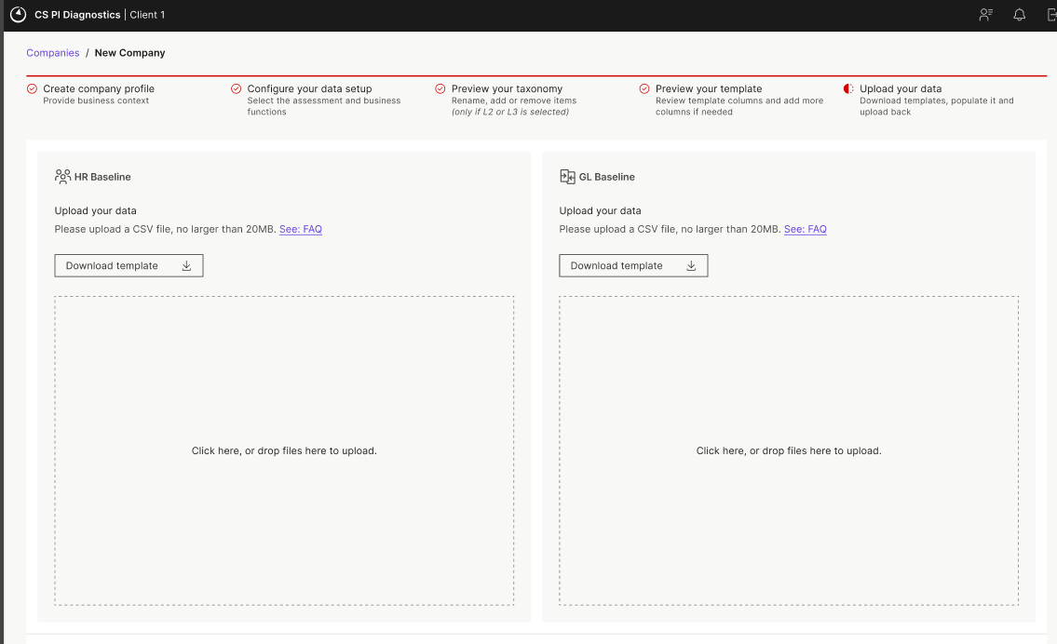
- Upload validations
Any files uploaded by the user go through multiple validations before the data is inserted in the database.
    - Columns check: The columns in the uploaded file are checked against the list of columns selected in previous steps. In case of any missing columns or additional columns, an error is displayed on the screen which lists the missing/additional columns. Users need to update their files and reupload the files OR they can choose to add/remove columns from the previous page to match the column list of their file
    - File specific validations:
        - Headcount/Outsource
        - Employee ID should be unique: Employee ID is not a mandatory field but if included the IDs should be unique
        - FTE allocation should be <= 100% : Capacity allocation of any employee cannot be more than 100%
        - GL
          - In case any validations fail, then the user is prompted regarding errors. They can download the error file which provides a list of error against each row specifying the validation which failed for that particular row. User can then fix the file and upload the file again after removing the error column.

- Preview templates
  - Once the validations succeed, user is shown a “read-only” preview of the uploaded file so they can cross check that the file has been uploaded successfully and correctly.

Data upload page
A. Purpose
The Data Upload screen allows users to upload the essential input files (such as HR Baseline and GL data) that provide the base client data for all the assessments
B. Core Functional Requirements

- File Upload Functionality
Upload Types Supported:
  - HR Baseline File
  - GL baseline file
Supported Formats:xlsx

- File Template Download
- Button to download sample/template files for:
  - HR Baseline
  - GL Baseline
- File Validation on Upload:
  - Check required columns exist (e.g., Employee ID, Function, Labor Cost, % Allocation)
  - Check for missing values in mandatory fields
  - Check if numeric columns contain valid numbers
  - A singe excel file to be downloaded as output with a list of errors found in the template. User will need to fix the issues and then reupload

C.Preview
- On successful validation, a preview of the uploaded file to be shown in a table.
- NO editing option to be provided at this stage
- User will have an option to reupload file in case of any issues
- Re-upload button to replace file
D.. Integration with Backend
- On successful upload:
  - Data is stored in case specific tables with no interaction with any other case data

Explore and adjust Baseline

Benchmarking
  - Tool Overview
Benchmarking assessment tool is used to run ben
  - Screens
The Benchmarking assessment tool section will have three pages :
- Benchmark Upload
- Explore Benchmarks
- Output
  - Benchmark Upload
This page is required to upload the benchmarking data to be used for the assessment.

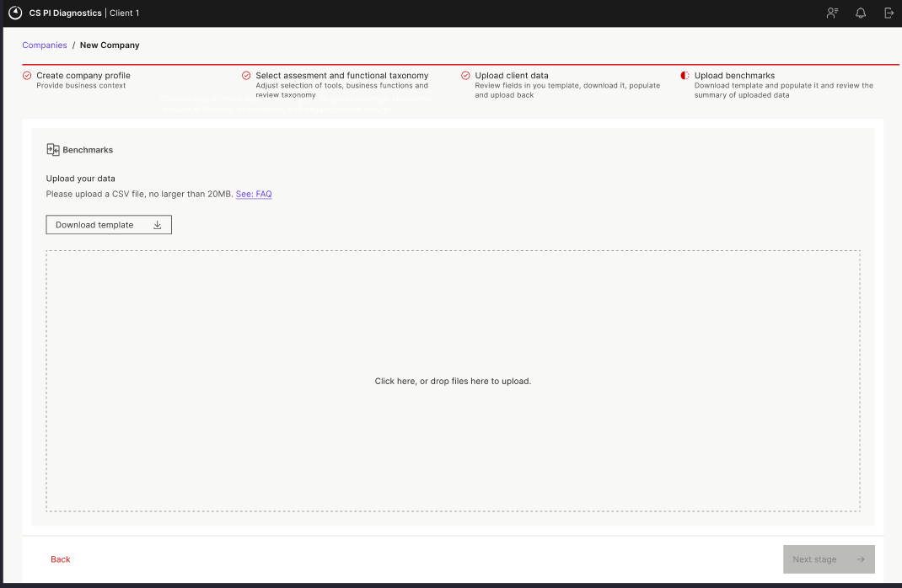

- Download Template: On clicking the “Download Template” button, an excel file is downloaded in the format shown below.

- The Template is prefilled with the taxonomy levels selected by the user on the Assessment & Taxonomy selection page.
- Any functions/processes/activities that have been modified or newly added by the user will be highlighted using a different font color
- To define the benchmark values for the same taxonomy level for different sets, users need to duplicate the rows
- For each level , the first row will be considered as the primary/default peer set for that combination. The default peer sets can be changed later from the “Explore Benchmarks” page

- Currently the tool offers the following 6 KPIs for comparison:
- Overall cost (needs GL):
  - Cost of X (for L1 function, L2 process or L3 activities) as a % of revenue
  - Cost of X per employee
- Number of employees (needs HC):
  - # of employees in X as a % of total employees
  - # of employees in X per $1B revenue
- Personnel cost (needs GL or HC; consider comment in sticker in GL columns slide):
  - Personnel cost of X as a % of revenue
  - Personnel cost of X per employee
- Validations: Following validations are performed on the benchmarking data:
  - KPI values: Checks for the standard KPIs and if any unknown KPIs are present in the data then the above 6
  - Data type mismatch : % values provided for KPIs with % metrics and numbers for numerical metrics
  - Mandatory fields: Checks that none of the mandatory fields should be blank
Validations are performed on the uploaded benchmarks and error file generated similar to the Baseline error file. User would then need to fix the errors and reupload the data
- Benchmark preview : If the file validation is successful, a preview of the updated data is displayed to the user. This is read-only and no editing can be done in this preview. In case the user wants to update the data , they can use the “X” button on top right corner of the preview screen . Alternatively, user can also navigate to the “Explore Benchmarks” page to edit the data.
- Benchmark Summary preview: Using the toggle on the preview page, user can switch the preview page to a summary view. This view shows the count of benchmarks available for each taxonomy level for each KPI. Any taxonomy elements which are present in the baseline data but there is no benchmark provided for them in the uploaded file are highlighted in different color.

Once the user verifies the uploaded benchmark data, they can click on the “Next” button to look at the final analysis.
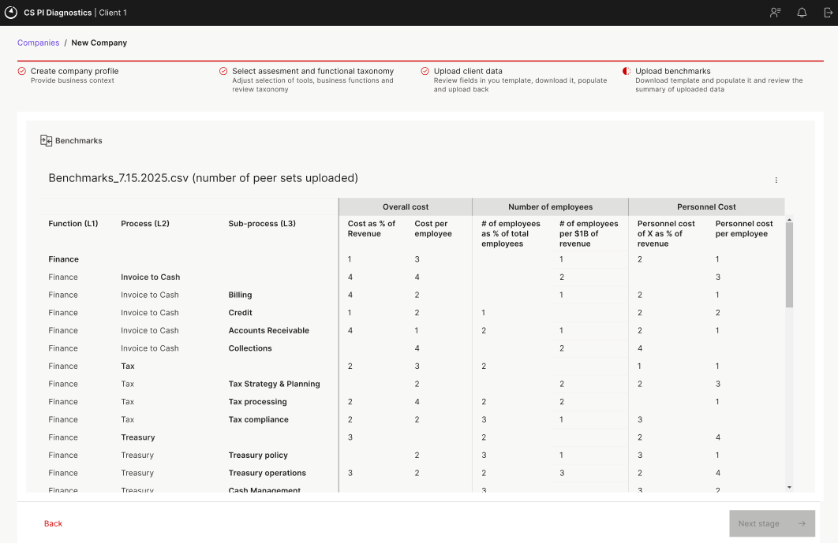
1 Benchmark Summary: No of peer sets

  - Explore benchmarks
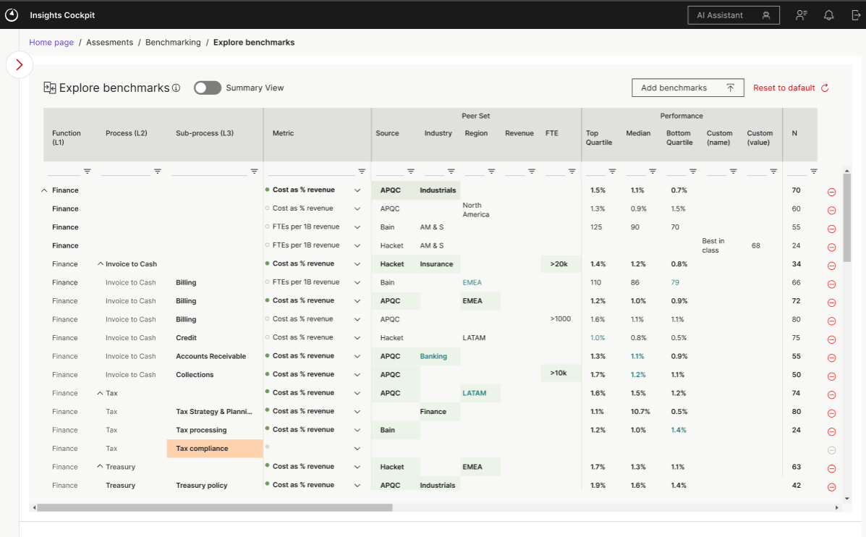
This page provides an Editable table for the Benchmark data.
This view will also show a data views and a summary view, but the summary view will not be editable.
In the data view, users can edit existing benchmark values , add new benchmarks and delete benchmarks. It should be noted that this is specific to the current case and changes do not have any impact to benchmark data being used for any other case.

“Reset to Default” functionality on the top will reset the page to its last saved status of the data. The “-“ sign can be used to delete a benchmark from the data.

In order to add new data , user can click on the “Add benchmarks” button. This is similar to the upload page in the Tool Setup and the user will need to upload new benchmarks data via an excel upload. It should be noted that the excel should contain only the new data rows as this is an append functionality. The old data will not be overwritten by this file upload. The validations for the file will remain safe. In case of any duplicates, the system will remove them by itself and provide a notification to the user.
In case of any error, a benchmark failed status will be shown and error file can be downloaded.
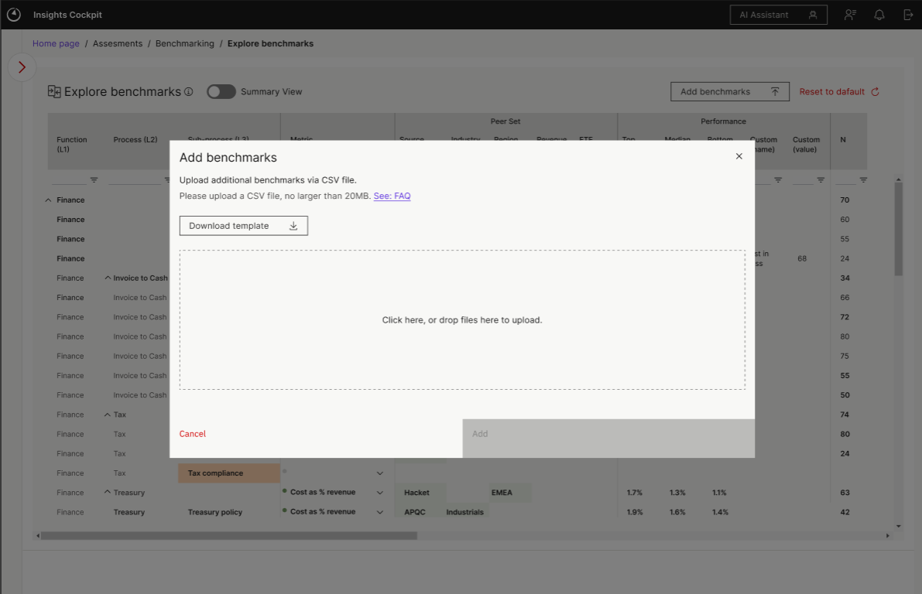
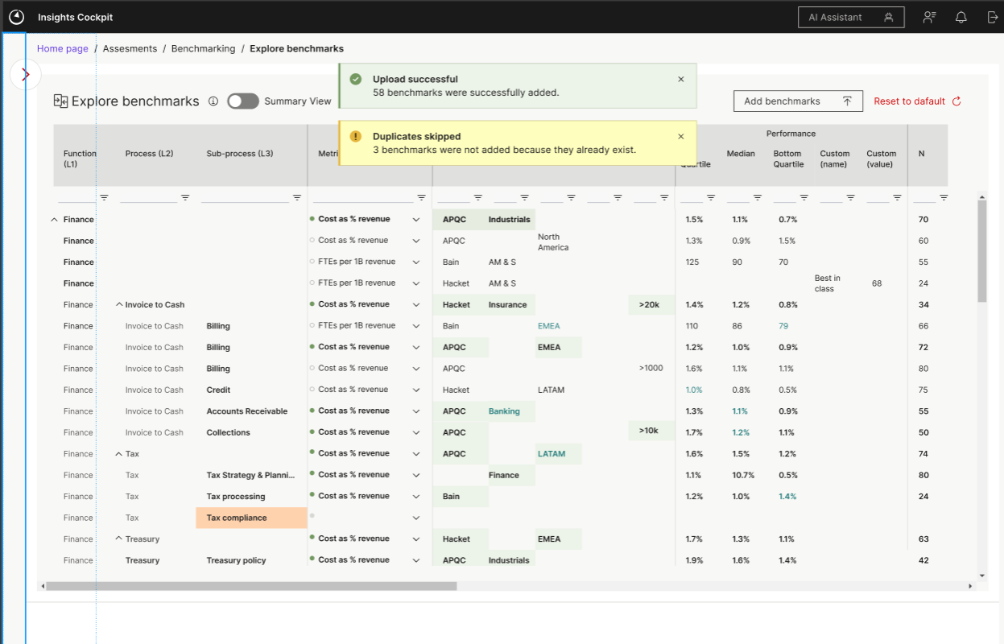
  - Output
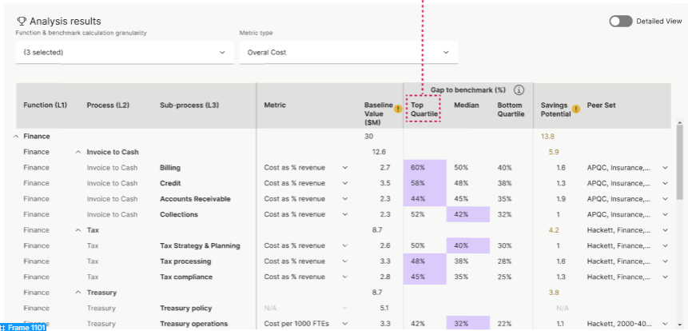
Output page provides the benchmarking comparison between the client values and benchmarks uploaded. It contains two views: Summary and Detail view
Calculations for Client value:
- Cost as % revenue :
- Cost of X taxonomy per employee
- # of employees in taxonomy X as as % of total employees
- # of employees in X per $1B revenue
- Personnel cost of X as a % of revenue
- Personnel cost of X per employee

Summary view:
Summary view shows the analysis data for one KPI and peer set at a time. When the user first lands on the page , the view shows a “default” scenario with the taxonomy selected by the user during Tool Setup at the highest granularity. The default metric and peer set are selected. User can chose to change the granularity for each function individually .
Detailed View:
The Detailed view shows the analysis data for all the KPIs available for each taxonomy level but only for one peer set. User can choose to change the peer set at a row level. This view also shows the calculated client value for each KPI.
“Gap to Benchmark” : it should be noted that both the views do not show the actual benchmarking values but only the % gap of the client’s KPI value to the benchmarking value. The user can chose which quartile they want to compare to (Top/Median/Bottom/Custom value) and the savings potential is calculated corresponding to the selected quartile. The selected quartile is highlighted in a “purple” color.
In the “Gap to benchmark” column, a blank value means that no benchmark is available for that quartile. A “-“ means that the client value is already better than the quartile benchmark.
Saving a Scenario:
User can create new scenarios or save old ones (except Default, which would always show the original values). The Save functionality is an event based Save where the scenario gets saved when a user creates a new scenario, switches to a new scenario or moves to a different tab.

Shared Services
  - Tool Overview
The Shared Services Opportunity Indicator (SSOI) is a strategic analysis tool designed to help organizations evaluate, model, and optimize their shared services footprint across business functions such as Finance and HR etc... It supports data-driven decisions for transitioning operations into centralized shared service centers and enables users to simulate multiple future-state scenarios, estimate cost savings, and understand organizational impact.

  - Functional Objectives
The tool enables users to:
- Analyze the current state of functional personnel distribution.
- Define and apply benchmark-driven target models.
- Simulate scenarios for shared services adoption.
- Estimate financial impact and FTE movement.
- Generate comparative outputs to aid executive decision-making.

  - Screens
Shared Services tool can be divided into three major sections:
- Overall Assumptions
- SSOI Benchmarks
- Site Selection
- Resource allocation
- Site allocation
- One off cost assumptions
  - Transition costs
  - Severance costs
  - Other one-off costs
- Output
  - Savings and FTE evolution
  - Annual run-rate savings
  - FTE impact overall view
  - FTE shifts
  - One-time cost overview
  - Calendar view
  - All data table

  - Overall assumptions
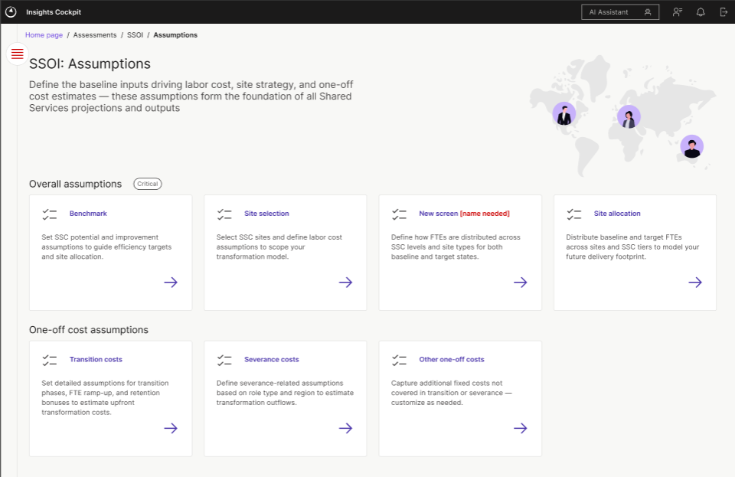
This is the main landing page for the SSOI tool. Inputs in the Benchmarks, Site selection and Site allocation pages are compulsory inputs as they provide critical data for the tool analysis.
- SSOI Benchmarks
Benchmarks page is the first page in the SSOI Assumptions module. It is a compulsory input page which a user needs to interact with.
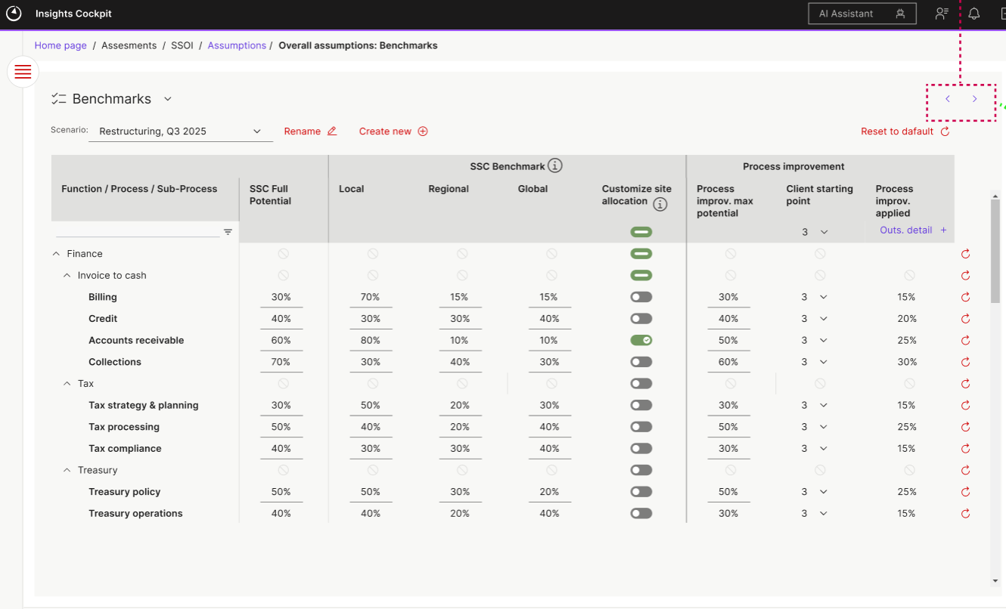
The first columns is the “Taxonomy” column which will show the L1/L2/L3 in a tree data structure.
The column will only show the taxonomy levels selected by the user for the SSOI analysis even if benchmark data is available in the database for other levels.
Benchmark data will be pre uploaded by COE team from backend. This is a common data for all cases, however case specific changes can be made by users.
The page has two sections - Benchmark data and Process Improvement data.
Benchmark section shows the actual values from the Benchmark file. These values are editable but validation will be done that the sum of Local, Regional and Global columns always should be equal to 100%.
If a user has defined a custom taxonomy , then the row is shown as empty and the cells are highlighted with red borders
For the PI section, the “client starting point” is set to 3 by default. This point can be changed by the user with range from 1-5 (1 being the least mature and 5 – most mature)
“Enabled Site Allocation” column is a toggle column which can be used to provide details about a certain site. If a user toggles this ON for any site then the site gets displayed in the Resource allocation page where further details can be provided.
If a user attempts to leave page without resolving any error, following error should be shown:
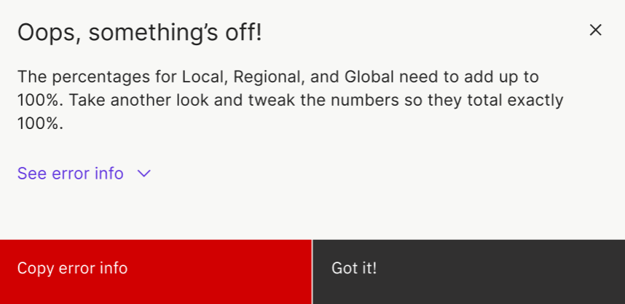
If they still choose to Save then we show a warning sign on the Assumptions landing page.
On clicking Got It, user does not navigate away, they still need to stay on the page to fix the issue.
“Reset to Default” : This resets the benchmark to its last saved status. Eevery row also has individual “Rest to default” icons, clicking on these icons resets any changes made to that row.

- Site Selection
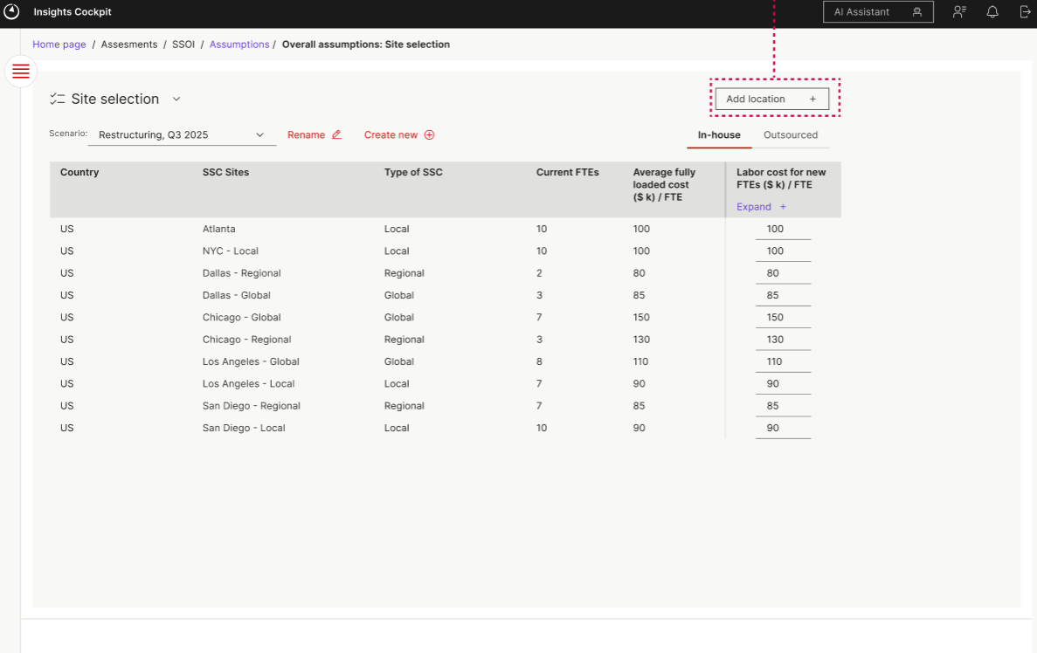
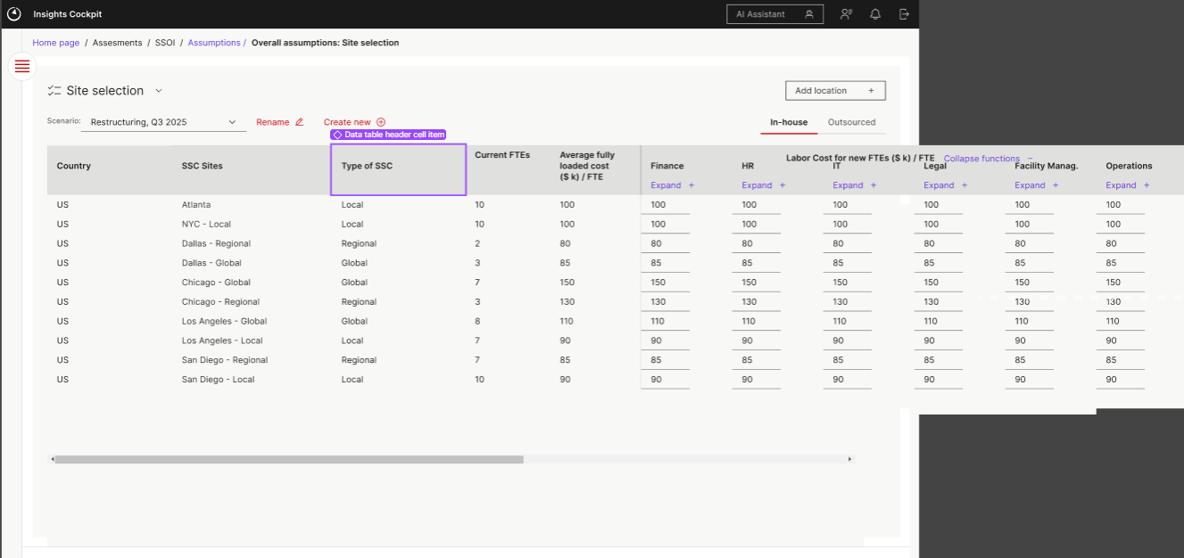
“Site Selection” screen can be used by the users to define the cost of labor at each site. They can define this at a site level or drill down to the lowest granularity level and define the labor cost at that level.
The default view shows the average labor cost for each site calculated from the baseline data. The “Average labor cost” is a read only column and cannot be edited by the user as it is the actual average labor cost from baseline data. However, user can propose a new labor cost for each site in the “Labor cost for new FTEs” column.
Users can also propose creation of new sites to comply with the benchmarking standards. However, this view is connected to the benchmarking view. If there is at least one % >0 in local or regional or global, user must have at least one equivalent site (e.g., one local if at least one process as a >0 in the previous, etc.). An error message would be shown to the user if the above condition is not met.

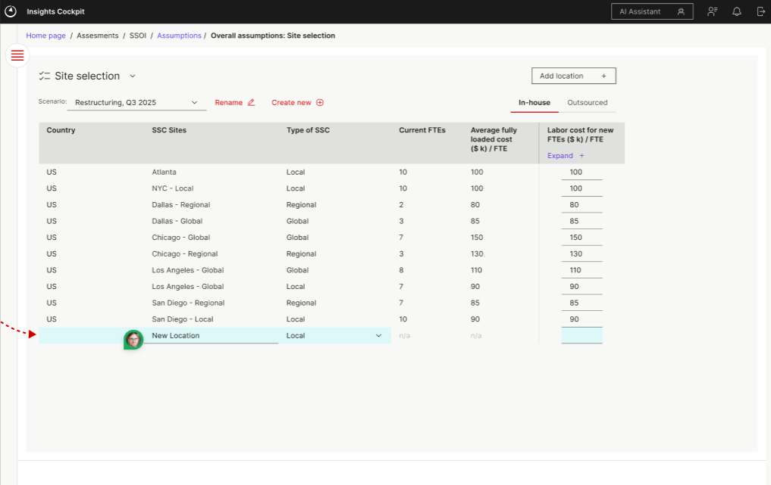

- Resource allocation
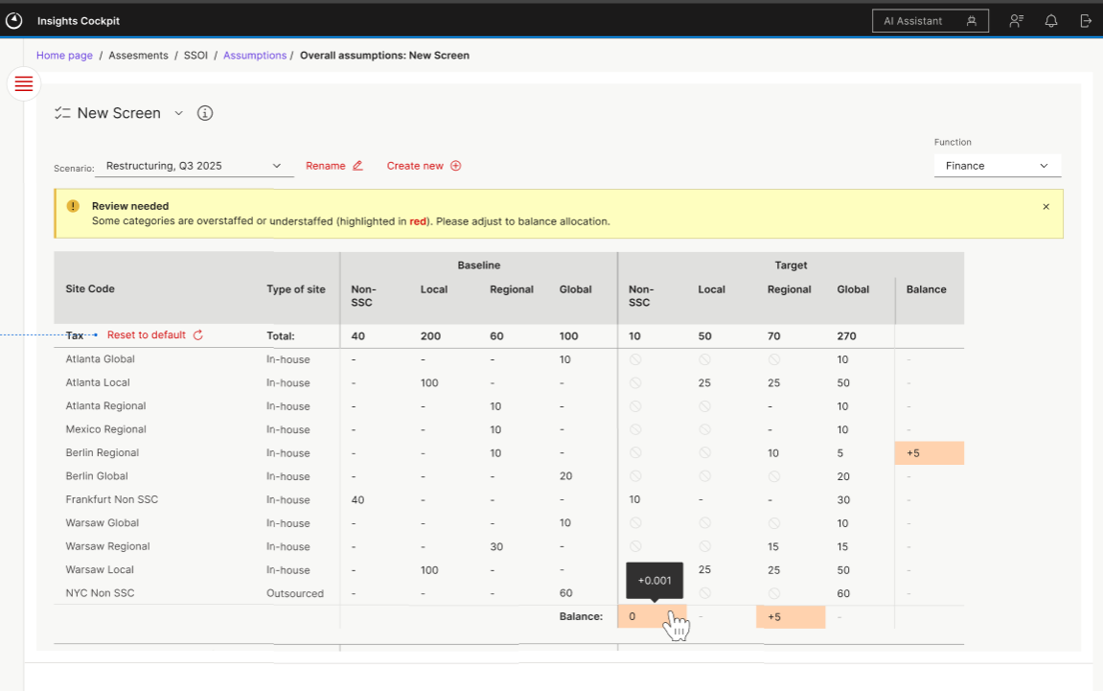

This view is an optional view. This is available only if the user selects the toggle in the Benchmarking view. It allows the user to change the resource allocation by site. It can be done only at a site level and at the lowest granularity of the taxonomy.
The values in the screen can be changed in increment/decrement of 0.1 and the total value of the allocations should always match the total FTE count. If the user changes any allocation, a balance is shown in last column/row. Users need to balance out rows or columns completely to match the total on the top of the column. An error is shown to the user on the page and on the home page if the allocation is not balanced.
Also, allocation is restricted by levels such that a resource cannot be moved from “SSC” to “Non SSC”, similarly, a top down approach is followed in SSC, such that a resource cannot be moved from Global site to Regional site and from Regional site to Local site but vice versa can be done.

- Site allocation
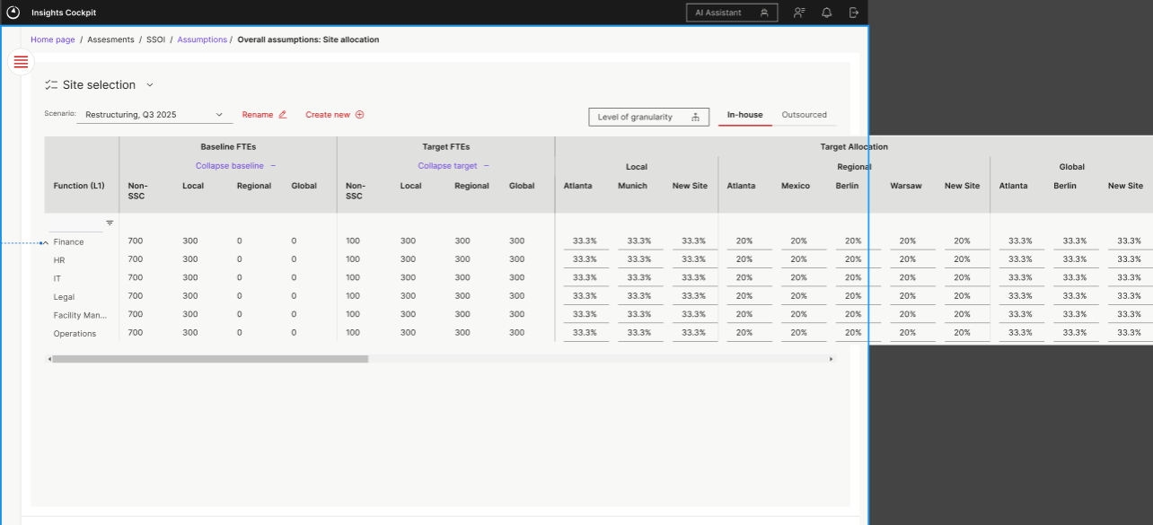
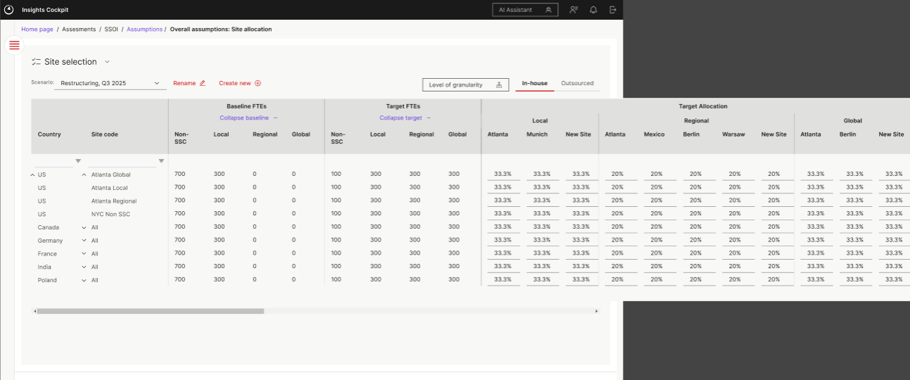
The site allocation screen is similar to the resource allocation screen but this is used to determine the target resource allocation on a function level for each site. By default . the allocations are predefined based from the “Site Selection” page. The user can change the distribution, however the total for each site (sum of Local, regional and global) must be equal to 100%.
This view is divided between the “Insource” and “Outsource” resources.

  - One off cost assumptions
- The one off cost assumptions are used to review the cost implications occurring from the allocations in site selection and site allocation pages. It is used to define the timelines and cost implications to implement the plan.

- Transition costs
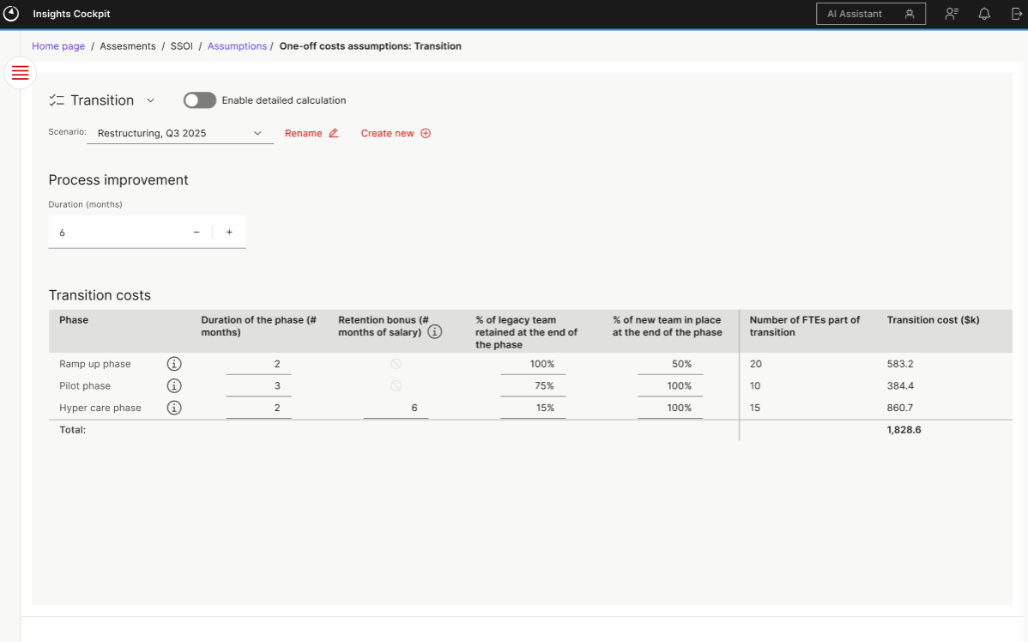
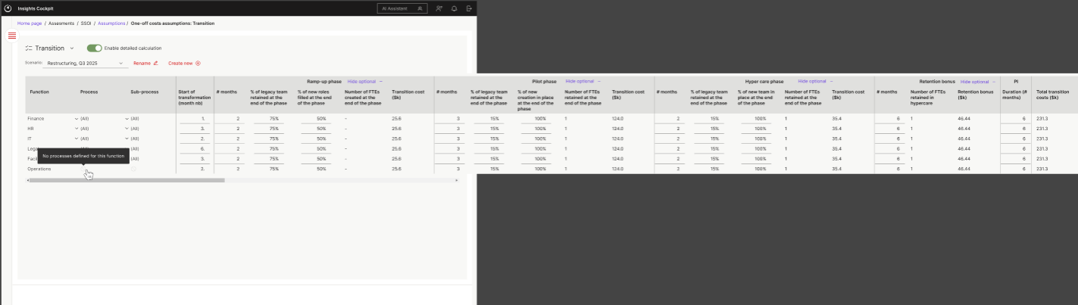
“transition costs” screen is used to define the expected period to implement the overall process improvement. The plan is divided into three phases. Time duration defined for these three phased forms the total duration of the process improvement plan. This screen is divided into a summary and detailed view.
Summary view provides an aggregated view for the three phases. The detailed view provides the details for each phase at a taxonomy level. This view allows the user to plan each phase individually for each taxonomy levels. The costs in this view are calculated from the assumptions defined in the previous assumption pages.

- Severance costs

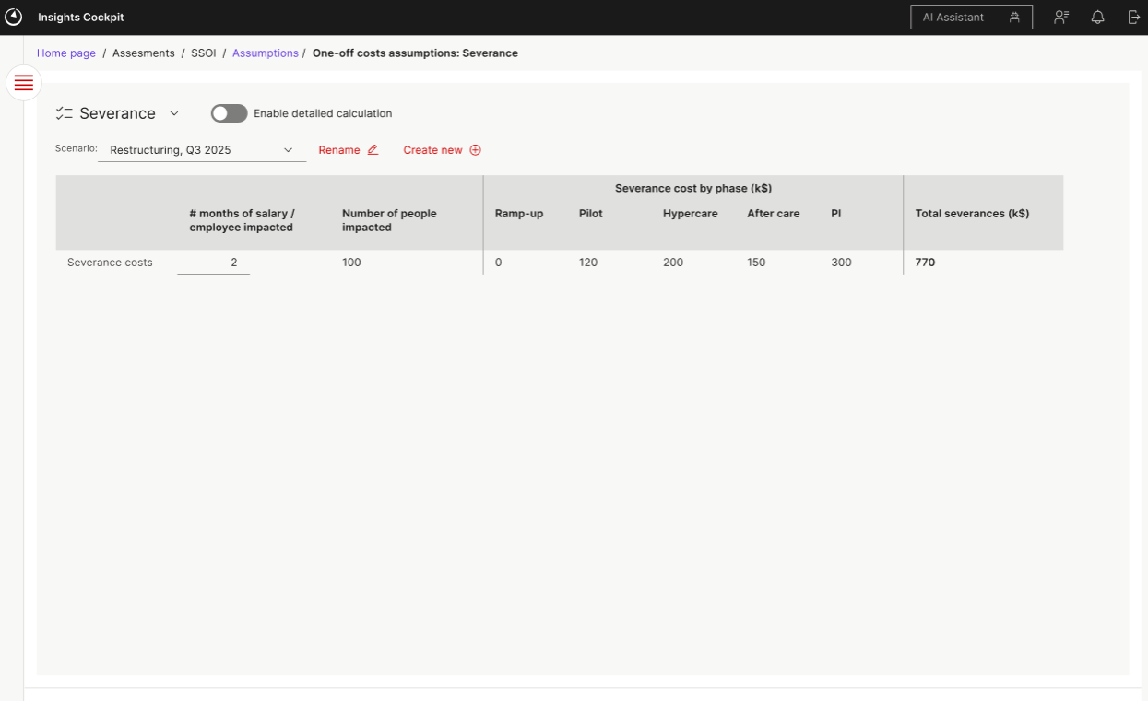
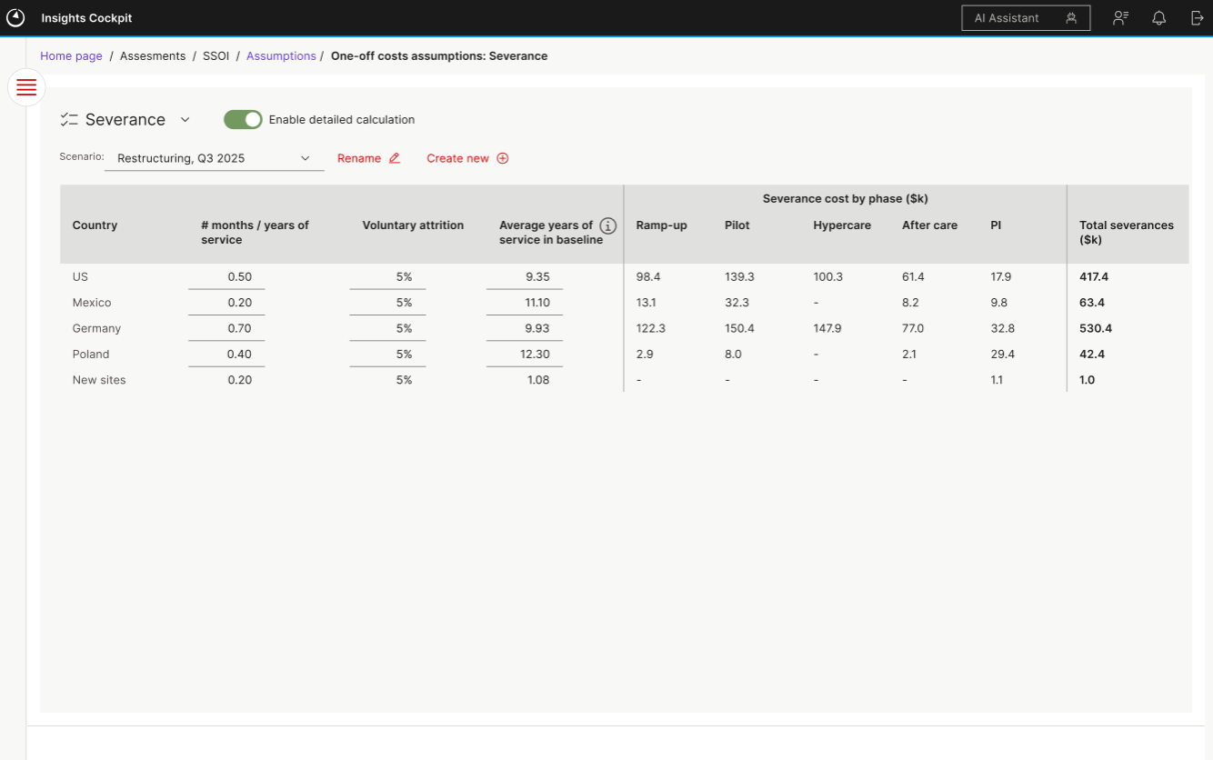
“Severance costs” view provides the estimated severance to be paid in different phases due to the changes in resource allocation.
In the high level view , it is shown as an overall aggregated value while the detailed view shows the cost at a site level. However, only those sites are shown which are actually getting impacted.
The “Average years of service” column is populated from the baseline data. However if the years of service is not available then the user can provide the years from their end.

- Other one-off costs
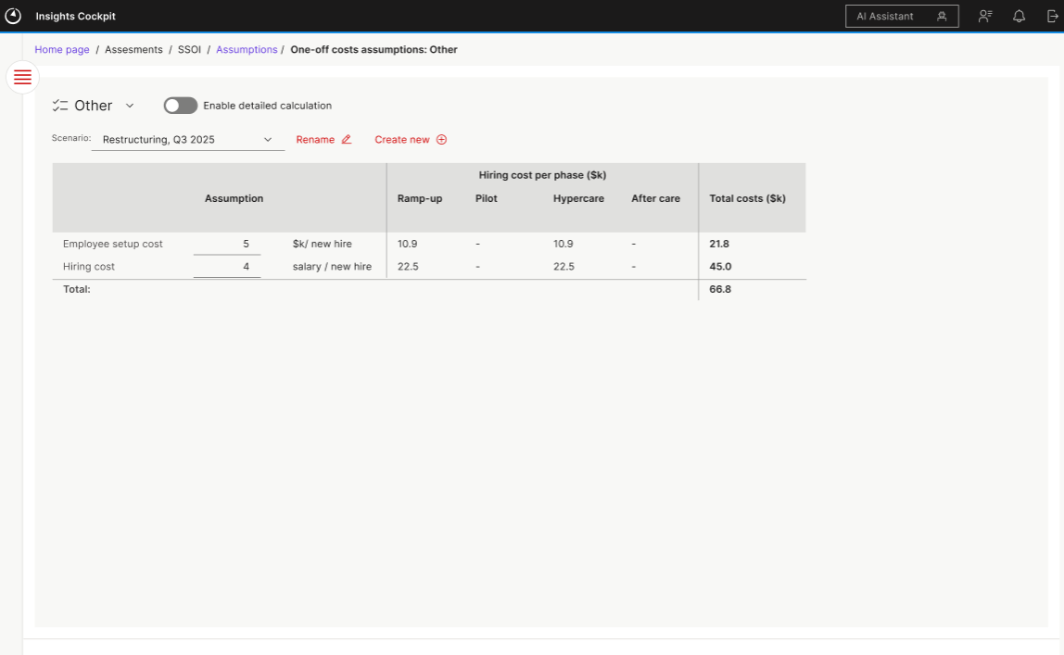

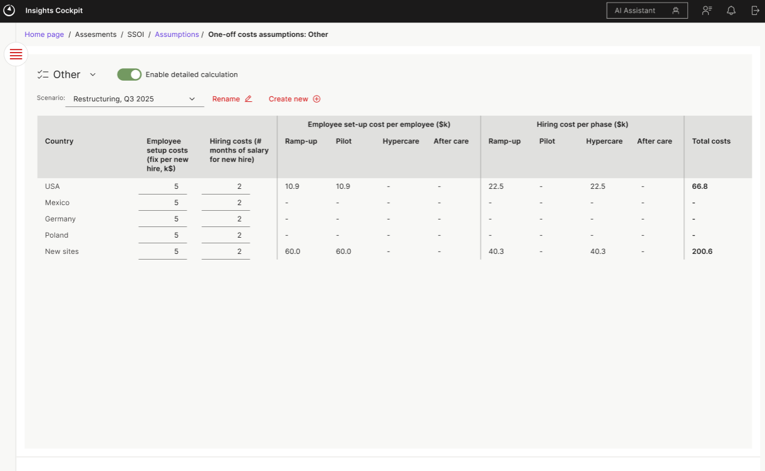

This view defines “Other” cost related to employees which are one off during the implementation phase. It has a “High level” view that shows the cost at an overall aggregated level. The detailed view shows the split of “other” costs at a country level and during each phase

  - Output

The output screens provide the final calculate values based on the assumptions defined. All of these views are read only views and only for reporting purposes. No changes to the data or assumptions can be made from here. Filters implemented on any of the views will also be implemented on all the other Output views.

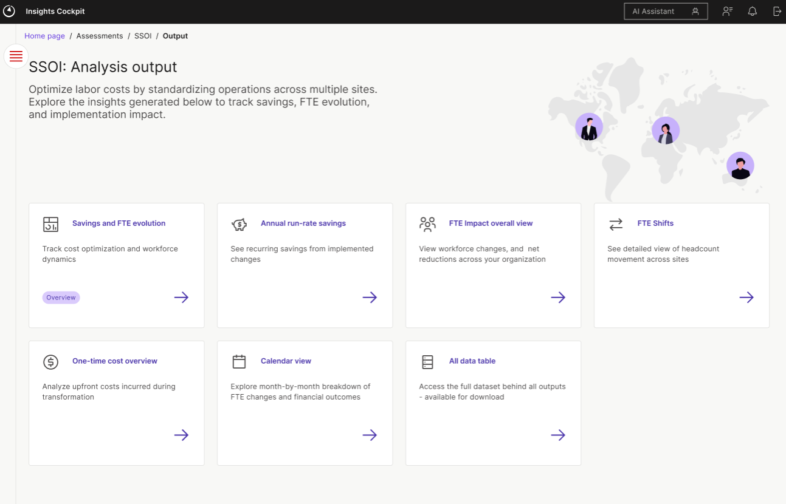

- Savings and FTE evolution
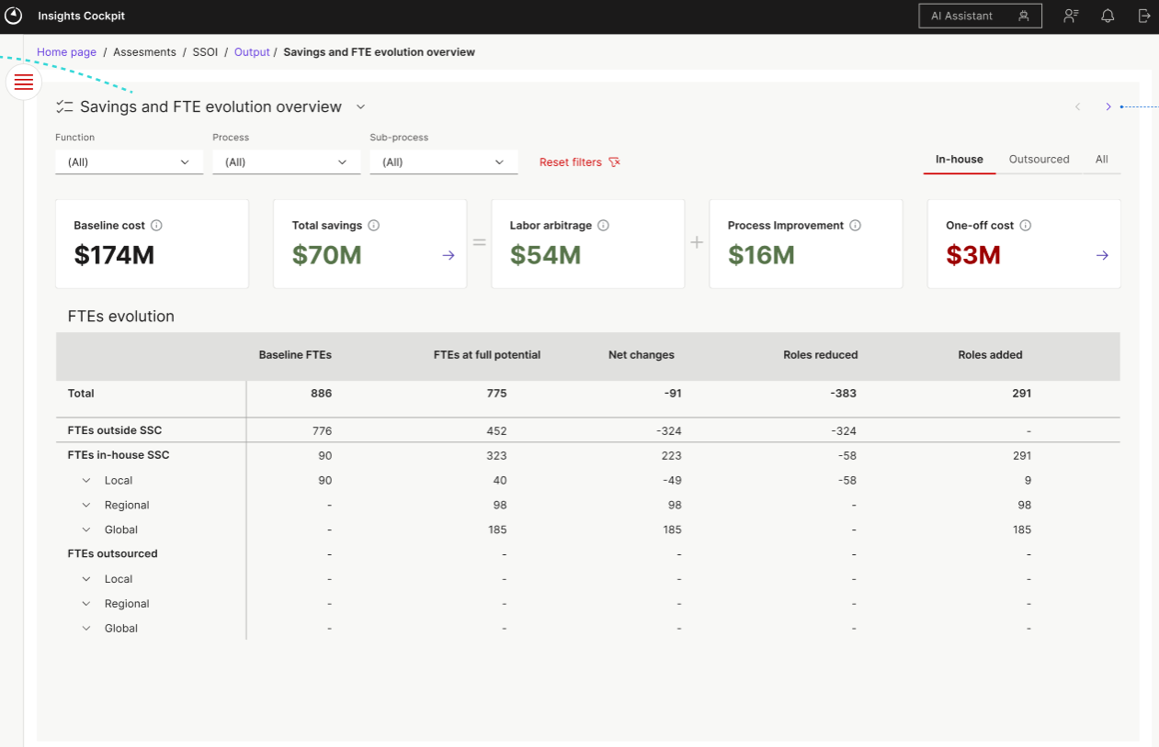
This view provides an overall aggregated view of the savings in terms of money value and change in FTEs across sites. Filters from this page are carried forward to all the other screens.

- Annual run-rate savings
This view is a deep dive view for the money savings reported in the previous view. It provides breakdown of savings at a function level. Users can view the savings for In-house/outsourced or All resources.
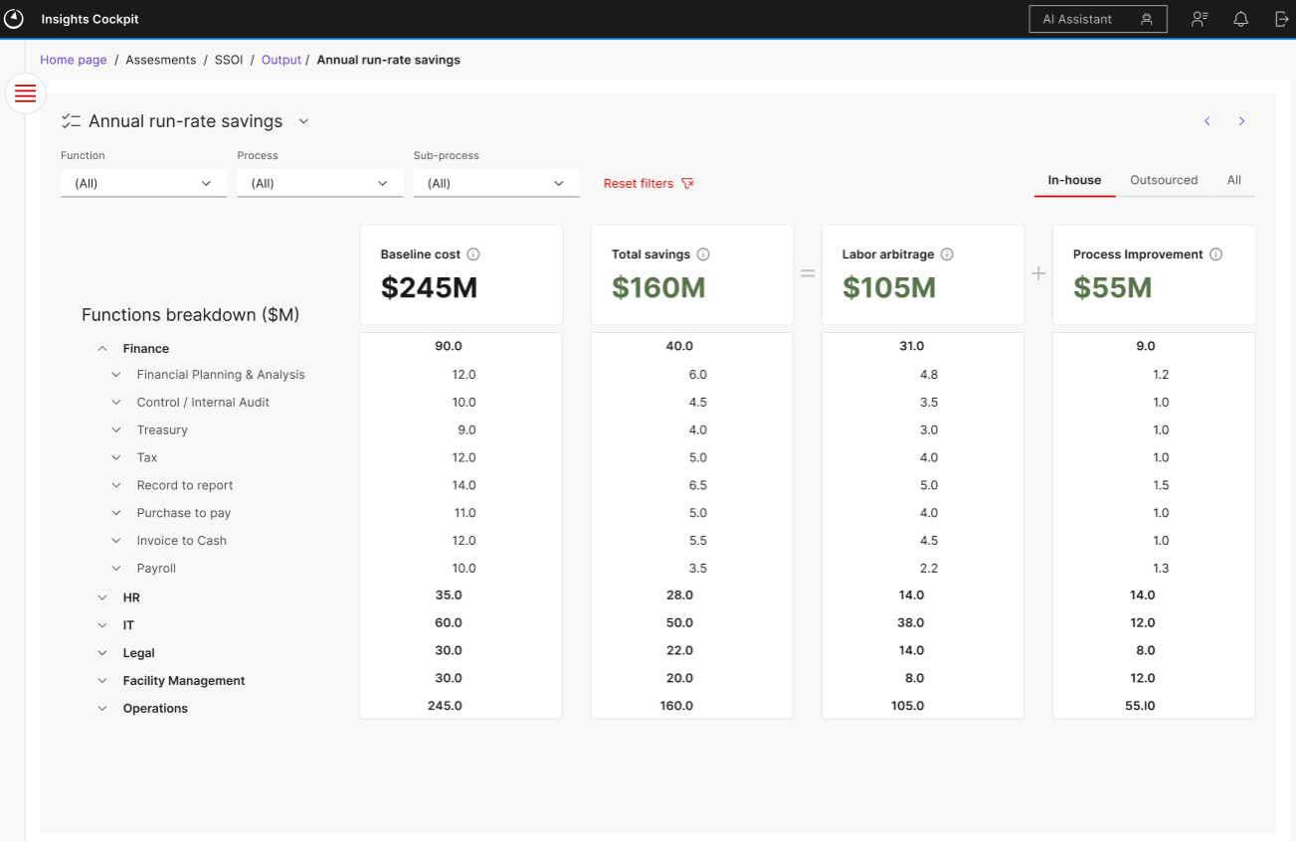

- FTE impact overall view
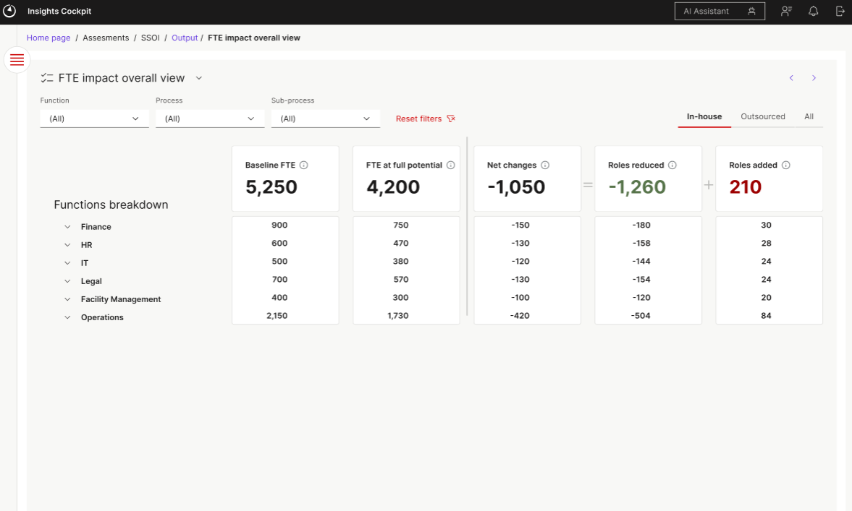
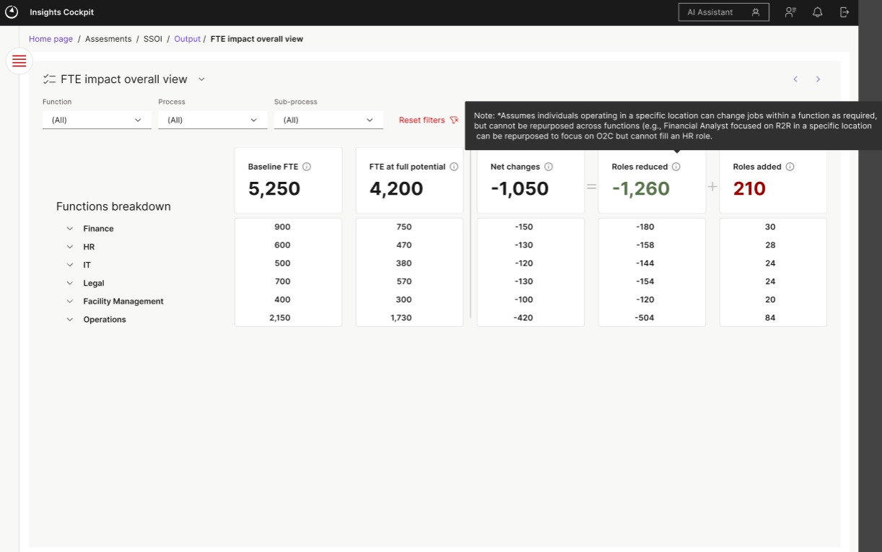
This view is similar to the view before but reports on the current state of FTEs instead of the money value. This view also reports breakdown at taxonomy levels.

- FTE shifts
The “FTE shifts” view reports the changes in FTEs from the Baseline value to the Target value at taxonomy level for each site. The user can view the values at an aggregated level by site types or further drill down to a site level.
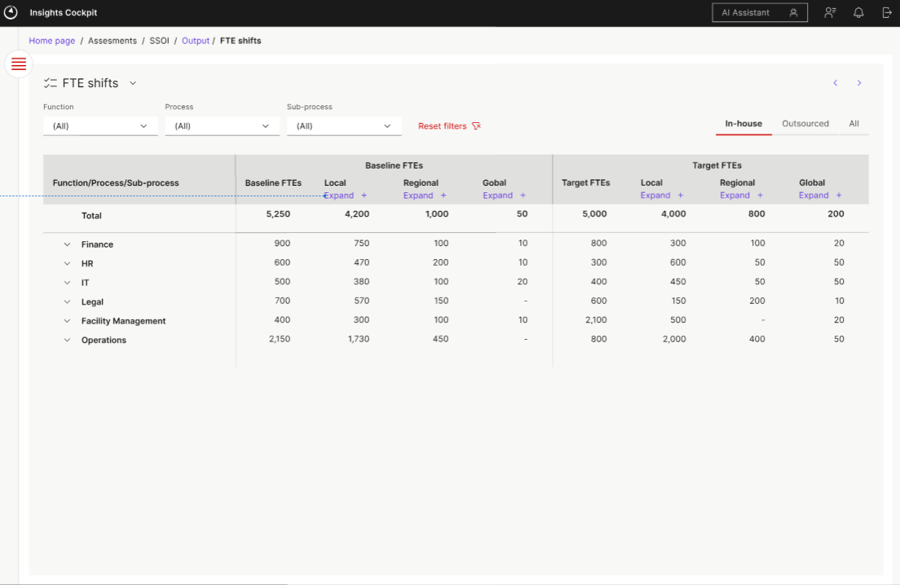
- One-time cost overview
This view provides a detailed view of the One time costs breakdown reported in the first view at a taxonomy level and split by cost types. 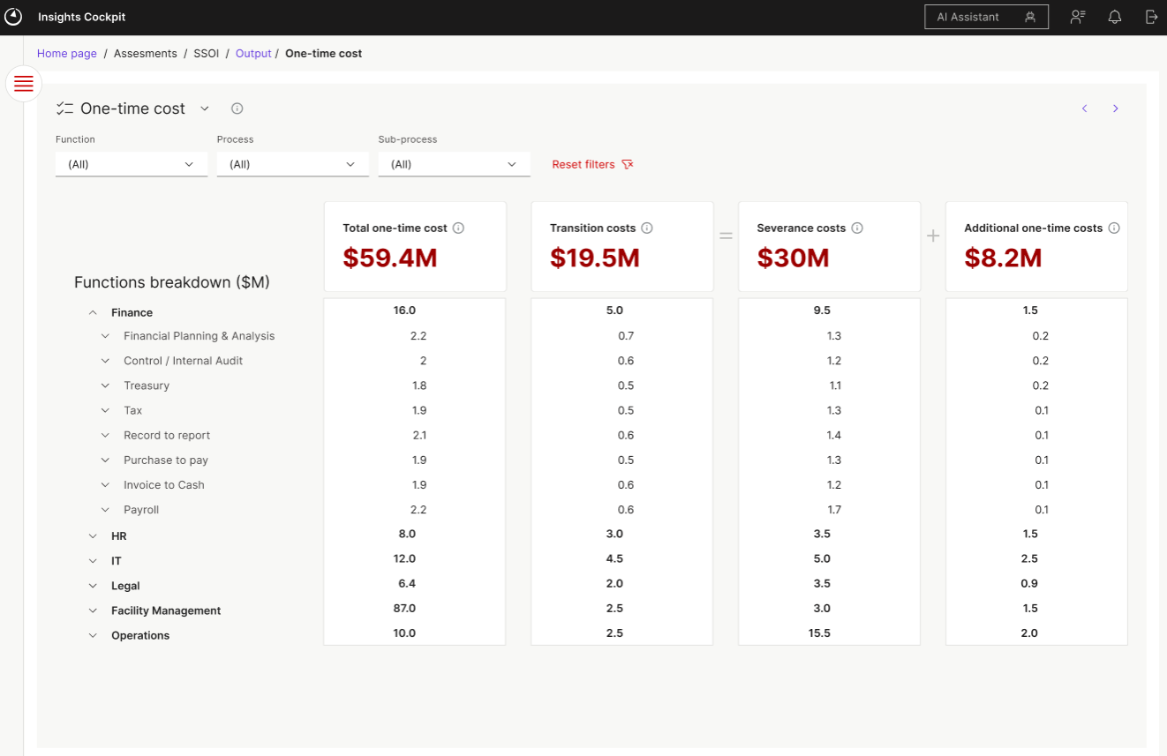
- Calendar view
The calendar view allows the users to view the changes in FTEs and savings in each month of the process improvement implementation. The values are reported with breakdown at a taxonomy level. Users can view at the lowest granularity or at an aggregated level.

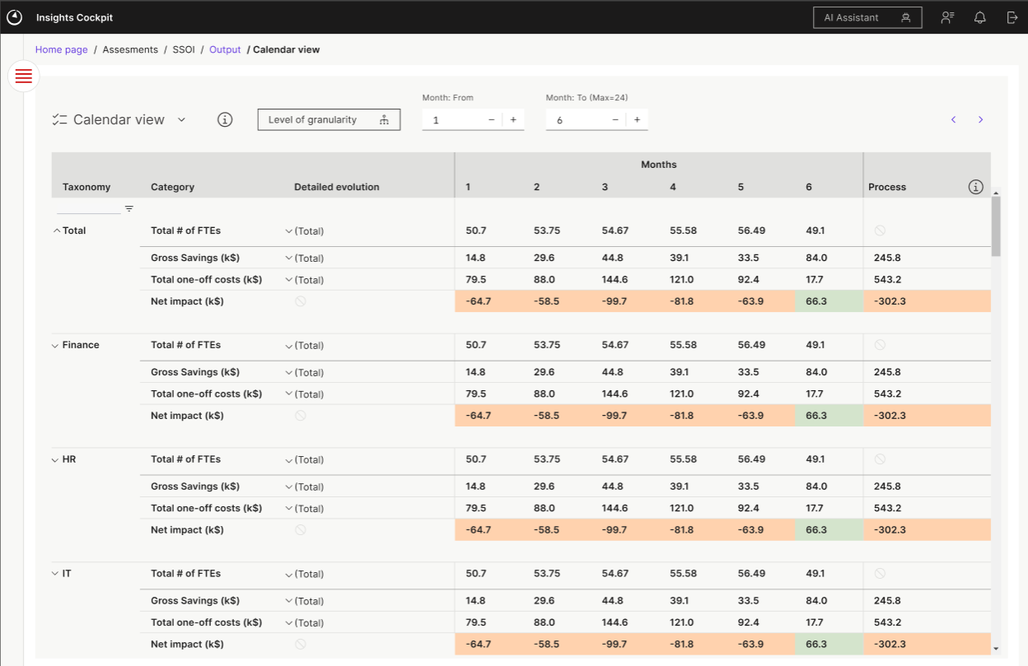

- All data table
(Figma TBD)
This view provides a combined tabular view of the output values broken down at taxonomy level.

  - Scenario management
SSOI calculations follow a top down approach. Changes made to an assumption or costs page has an impact on all the values in the pages coming after that page. However, there is no impact on assumptions/costs before that page. This has an impact on how the scenarios are managed for SSOI.
Scenarios in SSOI are global scenarios i.e a scenario create don one page is available on other pages as well. By default there will be a “Master” scenario which will have the original values and can not be edited.
Ex: If user creates a scenario “Scenario 1” on Benchmarking page , then when user moves to the “Site selection” page, they will see “scenario 1” already selected there. This scenario will be based on the values from the “scenario 1” on Benchmarking page. Similarly “Scenario 1” would be created for all the other pages in the sequence.

Automation

Cross-tool Integration

GenAI

Backlog

Advanced
- Level selection for non existent levels for an assessment: If a user decides to chose a level that does not exist for an assessment, they would get a popup saying the level doesn exist for the assessment and the user needs to define the level hierarchy and provide relevant data

Good to have
- User roles: Define roles like Admin, COE User and Consultants having various levels of access. Admin can have access to any case. COE users will have access to a limited no of cases and consultants will have access to only their current active case

- Admin page: Page for admin users to control access of users, add/remove/modify users. Delete/wipe old case data. Access to usage logs for the app

